CCN

Lab 1

Kip Taylor

1. 172.19.160.1



1. Google.com = 172.217.7.174



1. Here

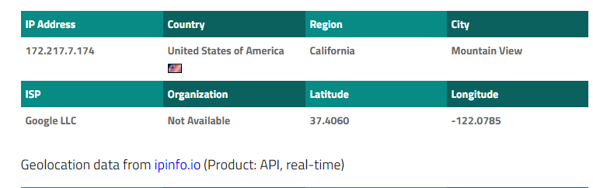

1. Formula ( my access delay = 10 ms

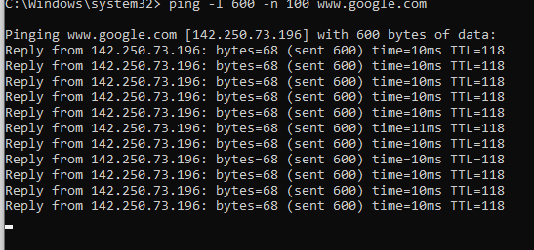

1. Answers below
2. They are not similar. 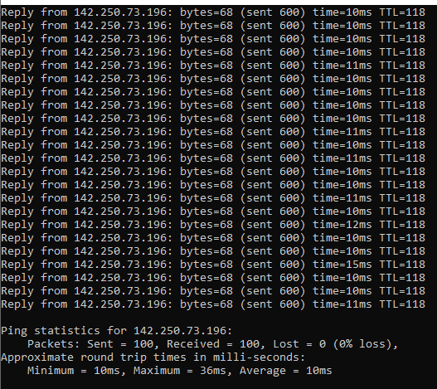
3. Histogram below .

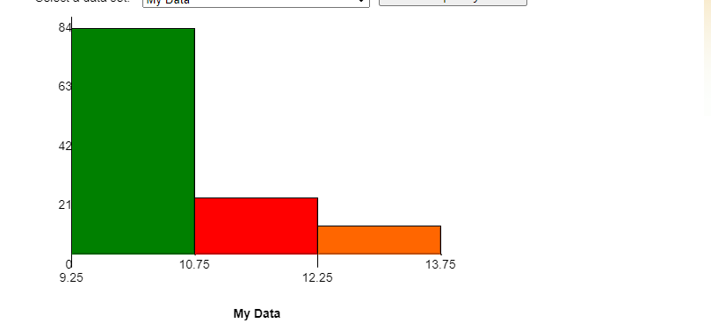

1. is the same time almost always , so roughly 88% the time is 10 ms, 5% 13ms , and the rest its 6% 11ms, one was 36 ms though.
2. mean was 10.883453ms. ( given by the pc) , variance calculation) is 4.0051265
3. An appropriate time is around 21 ms or twice the average or the between the variance and mean.